## COVER PAGE TITLE GOES HERE

## Solution Design Proposal

### JD’s Babbitt Bearings, LLC

Solution Design Proposal v3

Presented To: Jarad Finney

6/12/2015

# Code Authority ContactS

|  |  |
| --- | --- |
| **Name** | Nick Schulte |
| **Phone Number** | 214-774-4262 x115 |
| **Fax Number** | 972-668-2926 |
| **Email** | nschulte@codeauthority.com |

|  |  |
| --- | --- |
| **Name** | Adam Ferguson |
| **Fax Number** | 972-668-2926 |
| **Email** | aferguson@codeauthority.com |

# Proposal Detail and Plan

## Client Needs Assessment

JD’s Babbitt Bearings manufactures and repairs Babbitt bearings. These bearings are used in many mechanical and industrial applications for power plants, motor shops, energy providers, and much more. Companies from around the world send in bearings to have them cleaned, inspected, and serviced.

The current business process for incoming jobs is done manually and requires a lot of oversight. JD’s needs a solution that relieves some of the burdens of overseeing the simultaneous production and delivery of multiple products, while keeping a strict time schedule.

The process of tracking each product as it moves through a custom workflow can be complicated and hard to follow. JD’s needs a vendor that has experience working with large data workflows, transforming raw data into clear and concise forms, and experience presenting data in a way which is informative, actionable, and interactive.

JD’s Babbitt Bearings has an established brand standard which is reflected in their products and reliability. This brand standard is a reflection of their identity and professional values. JD’s needs a software vendor who has experience adhering to brand standards and designs; developing easy-to-use, professional user interfaces with logical entry of data; and who can collaborate effectively with their branding team.

JD’s customers will rely on this solution to check the progress and status of their products. JD’s needs a custom software vendor that can create simple, light-weight pages that won’t bog down due to bandwidth or compute restrictions.

JD’s has a long term vision which will required more functionality and reporting to be added to this system. They need a vendor that can create an application that is modular, with separation of concerns, and which is developed with methodologies and standards that make it easy to enhance and add features.

# Code Authority Approach

We are often asked to estimate custom software projects in both cost and time to deliver. Estimating custom software projects is very inaccurate and borders on irresponsible without some time being spent investigating, and documenting the size and scope of the project.

Code Authority has unique method of providing “three costs” to build any project. We have been refining this process since 2001.

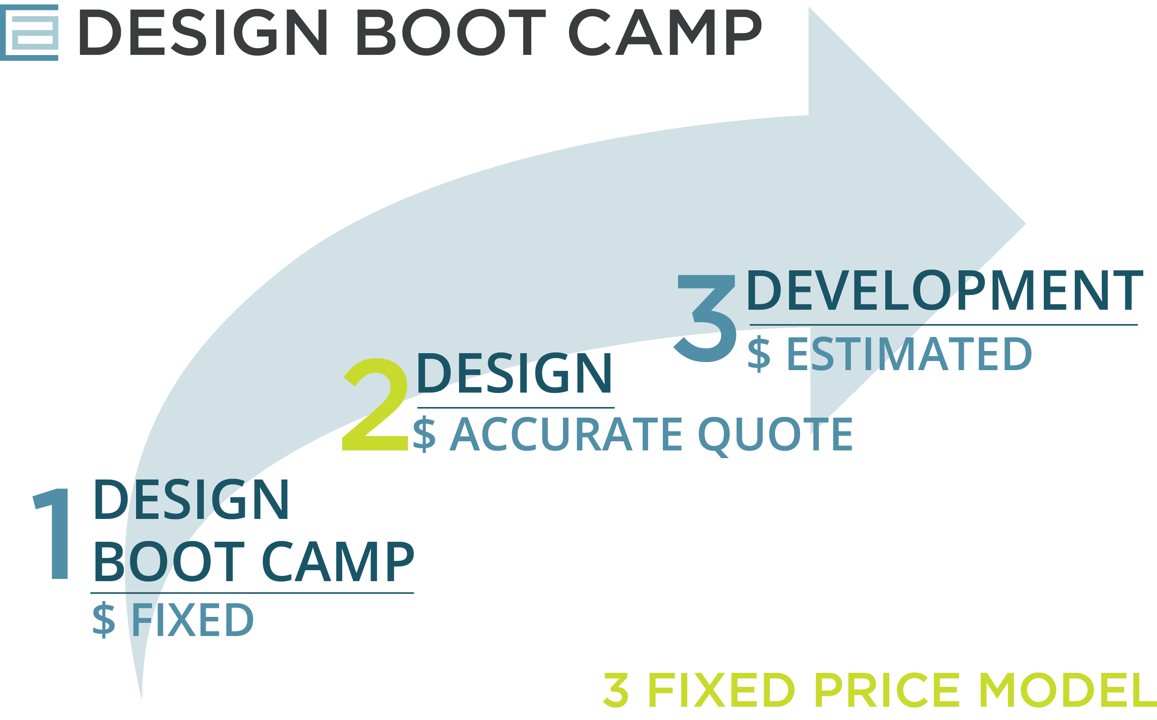

# Design Boot Camp

A useful tool in helping to remove ambiguity about how much a software project will cost, or how long it will take, is to engage Code Authority in a “Design Boot Camp” project. JD’s Babbitt Bearings has completed this step in our approach and the breadth and scope of this project is now known.

Draft versions of some of the design documents which would ultimately be finished in a full design engagement have been started.

# Design Engagement

Code Authority takes a unique *design-first* approach to custom application projects. Our design consultants engage with the client stakeholders and subject-matter-experts to extract information, formalize it in various types of documents, and then organize it into a “Project Blue Print”.

At a minimum, the following documents are created during the design phase and provided to our clients in both printed and digital form:

* Functional Specifications
* Technical Specifications
* Entity Relationship Diagram (Database Schema / Relationships)
* Database Dictionary
* Reporting and Business Logic
* Mock Screens representing most of the application user experiences.

Additional design documents or tools that may also be found to be necessary:

* UI Requirements
* Business Rules & (Formulas)
* Prototypes & Proof of Concept
* Web Service Specifications
* Use Cases or User Stories
* Out of Scope/Future Phase Considerations

The CA team will work closely with the client during the design phase. Multiple meetings will be held, and the design process will be iterative. At the end of the design phase then client will know exactly what the software is going to do and what it will look like. Both parties will have a blueprint for the software development phase. Both parties will agree design is complete.

# Development Phase

At the conclusion of the design phase, the client will be provided and own the software design documentation. CA will provide a quote wherever possible to engage in the development of the systems defined by the design documentation. A Project Plan and timeline will also be provided.

### If the client finds the CA bid unacceptable the blue print can be leveraged to solicit competitive bids.

Prior to launch, a typical development phase client will engage in *customer driven* *beta test*s where the delivered application is proven to be acceptable and ready for adoption into daily business. CA will work closely with the client to address all functionality gaps within scope until the application is ready for launch and adoption.

# Design and Quote Topics

## core workflow functionality

* Login as either an employee or manager
* Search for jobs
* Add/edit jobs
* Add parts to an existing job
* View/edit the part’s workflow
* Add/manage customers
* Add/manage employees and skills
* Manage employee profile
* Workflow overview diagram on 60” screens
* Create custom workflows for the following parts: bearings, thrust shoes, tapered land thrust shoes, oil deflectors, oil seals, hydrogen seals, slinger rings, thrust plates, and miscellaneous manufacturing parts

## customer facing website

* Public website with the “who we are, what we do” pages
* Customer login portal
* Customer “view my jobs” page

## Job merge

* Choose two existing jobs and combine the parts
* Create a new job and link it to the old jobs

## timesheets

* Add/edit/view daily timesheets
* View timesheets summary with aggregated time

## vacation

* An employee can add vacation days to a company-wide calendar
* Any time an employee needs to request vacation on a day that already has two other employees taking vacation, the time must be approved

# Pricing

After completing the Design Boot Camp process, Code Authority is now able to provide JD’s Babbitt Bearings with the following estimations in good faith of what the design and development costs would be. After the full project design, we will be able to give JD’s a quote for the full project development.

## Optional Components

The identified design and development components estimates below are intended to be standalone. Depending on the priorities of each respective item, the design or development effort for individual components can be earmarked for possible approach at a later date.

## Design Hours and Cost

Below is our quote for the design of the solution. The below Design Hours are our best estimates on the probable duration of the design. You will pay the hourly rate for any time spent on the design. If the design does not take the indicated estimated hours to complete, you will not have to pay as much as the estimated cost. If the design takes longer or the scope is increased, you will pay more.

|  |  |  |  |
| --- | --- | --- | --- |
|  | **Design Hours** | **Rate** | **Design Cost** |
| **Core Workflow Functionality** | **202** | **$108** | **$21,816** |
| **Customer Facing Website** | **30** | **$108** | **$3,240** |
| **Job Merge** | **24** | **$108** | **$2,592** |
| **Timesheets** | **25** | **$108** | **$2,700** |
| **Vacation** | **10** | **$108** | **$1,080** |

## Hardware and Infrastructure

Estimates for the hardware and infrastructure components are provided by John Barfield of Barfield Information Systems and Services (BISS). See the document titled “JD’s Infrastructure Quote” for the itemized list of products and services. The total cost estimated for hardware and infrastructure is **$16,702.35**.

## Estimated Development Hours and Cost

Below is a chart showing the **estimated** **development** **time** **and** **cost** for this solution.

Once the design has been completed, we will create more accurate estimates for the development of the application and may present different payment options or packages.

### Hourly Options

|  |  |  |  |  |  |
| --- | --- | --- | --- | --- | --- |
|  | Development Hours | |  | Development Cost | |
|  | **Low Range** | **High Range** | **Rate** | **Low Range** | **High Range** |
| **Core Workflow** | **606** | **808** | **$125** | **$75,750** | **$101,000** |
| **Customer Website** | **90** | **120** | **$125** | **$11,250** | **$15,000** |
| **Job Merge** | **72** | **96** | **$125** | **$9,000** | **$12,000** |
| **Timesheets** | **75** | **100** | **$125** | **$9,375** | **$12,500** |
| **Vacation** | **30** | **40** | **$125** | **$3,750** | **$5,000** |

### Fixed Price Options

|  |  |  |  |  |  |
| --- | --- | --- | --- | --- | --- |
|  | Development Hours | |  | Development Cost | |
|  | **Low Range** | **High Range** | **Rate** | **Low Range** | **High Range** |
| **Core Workflow** | **606** | **808** | **$155** | **$93,930** | **$125,240** |
| **Customer Website** | **90** | **120** | **$155** | **$13,950** | **$18,600** |
| **Job Merge** | **72** | **96** | **$155** | **$11,160** | **$14,880** |
| **Timesheets** | **75** | **100** | **$155** | **$11,625** | **$15,500** |
| **Vacation** | **30** | **40** | **$155** | **$4,650** | **$6,200** |

## Project Structure

Our projects are developed with a phase and milestone structure that keeps the client informed of progress at all times and also allows for **clearly delineated points at which payment for fixed cost items can be invoiced**.

## Third Party Components and Material Costs

Costs for any third party components, services, or materials have not be considered in the estimates provided. Those items will be invoiced at the time of purchase, if necessary. This includes any Microsoft Azure hosting fees for staging or production deployments. Photography for the customer-facing website is included in the estimate above.

# Terms & Conditions

## Invoices and Payment Terms

Any services following the Design Boot Camp will be provided under and executed Master Customer Agreement.

### Payment Terms Are as Follows:

Option 1 – Fixed Price:

Payment terms will be negotiated. Payments will be made based on parts of the project broken into delivered milestones.

Option 2 - Hourly:

Hours spent will be invoiced weekly.

Payments due are NET 30 from invoice date. More flexible payment terms will be made available to well-established clients.

### Limitation

The quotes provided encompass the design and development of the items which are ‘in-scope’ of the discussed system requirements. The scope of this estimate is defined by the design documents accompanying the estimate. Any functionality outside of this scope will incur additional design and development costs. An element does not have to be identified as Not in Scope explicitly to be out of scope.

## Delivery and Maintenance

Upon completion of the final Development milestone, the product will be delivered to JD’s Babbitt Bearings. After delivery, a 3 month period of customer acceptance begins. During this 3 month customer acceptance period, if the fixed cost option is chosen any bugs or issues which are found to be within the scope of the fixed cost elements will be fixed for free in a timely and professional manner. Bugs must be reported through the provided web interface. If the hourly option is chosen, bug fixes for hourly elements will be fixed at a rate of $80 per hour.

After the customer acceptance period, any bugs or other maintenance will incur an hourly cost.

## Validity of Proposal

This proposal is valid until **July 1, 2015.**